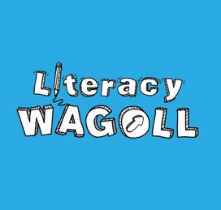

Advertising opportunities

Advertising with the Literacy WAGOLL can provide your organisation with a unique opportunity to access engaged literacy professionals who are not otherwise accessible to third parties.
Please see our different options below:
Literacy WAGOLL website  - Our website www.literacywagoll.com has over 20,000 monthly unique users  - The main audience for our website is UK and global education professionals  - Visitors use the site for literacy resources and teaching ideas.  - News stories focus on current news about our work and literacy in the UK  - Blog articles are posted through Medium and appear on our website. These are more personal and are linked to a current issue or event  Costs to advertise:  - Place a month-long advert to appear on the www.literacywagoll.com homepage: £250  - Write a guest blog (www.literacywagoll.com/blog) with image: £50 | Social media  - We have 1,500 Twitter followers and post between five and 10 times a day  - We have 2,000 likes on Facebook and we post once every day  - Our posts are image-led and cover our work, literacy trends and news of interest to our followers  - Our followers include teachers, teaching assistants and senior leaders.  Cost to advertise:  - A package of 4 Facebook and 4 twitter and 1 Instagram post: £25  - A package of 8 Facebook and 8 twitter and 1 Instagram post: £45
Blog posts  - Our website www.literacywagoll.com has over 20,000 monthly unique users  - The main audience for our website is UK and global education professionals  - Blog content includes teaching Ideas, PD, literacy trends and news of interest to our followers.  Costs to advertise:  - Write a guest blog (www.literacywagoll.com/blog) with image: £50  - Blog Mentions with link: £25 | YouTube Channel  - We have 1,000 views on YouTube and we post once every two weeks.  - Our videos are visual and engaging which cover teaching Ideas, PD, literacy trends and news of interest to our followers.  - Our followers include teachers, teaching assistants and senior leaders.  Costs to advertise:  - Brand plugs and reviews: £200  - Sponsorship of a theme: from £200

For more information or to book your advert, please email literacywagoll@live.com

