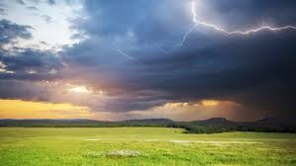
Dark purple clouds sprawl across the sky, billowing in from the west. The trees, etched different shades of brilliant green against their ever-darkening backdrop, stretch out their leaf-laden branches expectantly. The suffocatingly humid air grows heavy; the scent of rain is dark and heady on the stiffening breeze.
The birds fall silent. A stillness decends. For a moment, everything stops… Even the wind holds its breath until a jagged, startling, streak of silver splits the indigo sky.
A deep rumble of thunder growls in the distance like an angry lion announcing its presence. Increasing in intensity, it echoes round the hills, travelling across fields and villages, rattling the rooftops. Heavy drops of rain begin to splatter spasmodically onto the parched ground until, suddenly, the heavens open and the deluge is unleashed.

