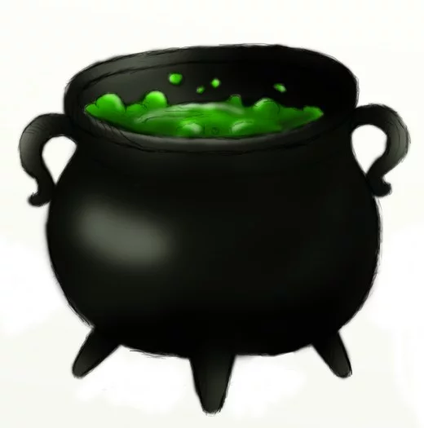
My spell makes my dog bigger until he is big enough for me to ride to Portugal on his back.

- A dragon’s cough
- A cat’s whisker
- 2 lizard scales
- A goblin’s laugh
- Salt and pepper.

First, put the cauldron on the fire. Then add the cat’s whisker and stir five times.
After that, put in a dragon’s cough. Next add the lizard scales and the goblin’s laugh.
Finally put in some salt and pepper and boil it up.

