Avatar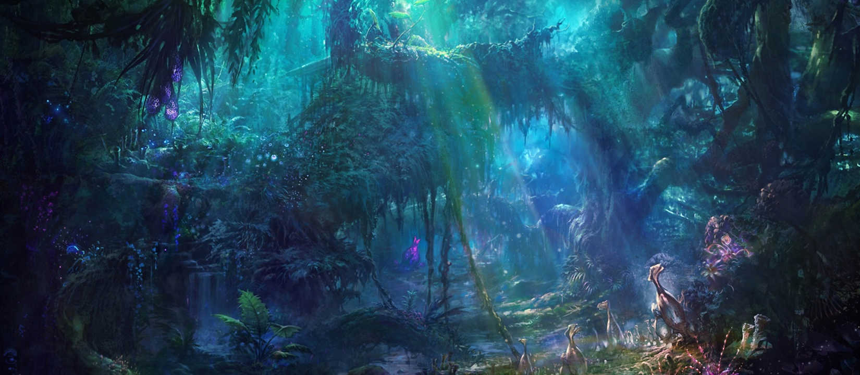
As the multiple moons exchanged places with the sun in the now azure sky, a misty haze began to form under the canopy of swaying, rugged trees. What was this place? Why was it so eye catching? Curling around thick spiraling branches were constricting vines, which braced and creaked. Dangling down from the layer of moss, vast, bold leaves flickered like church candle flames in breeze. Sweet scented pollen drifted through the archways created by the curving branches which created halos of light above and below.
However, the most delightful sight was the strange, exotic, unfamiliar plants which glowed bright neon colours. Sapphire, ruby and emerald pierced the sometimes dull surroundings - filling it with a song of life and colour. In addition, these supernatural forms danced and twisted as though keeping in time to some silent, environmental rhythm. This magical place was truly special, because even in the chaos of the natural surroundings, (where vines choked vines and branches beat down branches) it was perfect! It was hypnotizing! Although, there was still a sense that perhaps this was all a mask for a darker presence…

