The sun slipped behind the distant hills, painting the mountains red and black. Shadows lengthened, deepening the darkness. Wind whispered through the grass as if praying. Wearily, Tom and Jez picked up their fishing gear. It was late and they knew that they would be in trouble. But holidays only came once a year and they were just a mile from the cottage where they were staying. “Come on,” mumbled Jez, picking up his rod and turning to go.
At that moment, the boys froze. From somewhere overhead they heard a low whirring sound. Half a mile away a glowing light appeared. It streaked towards the forest and then hovered, casting beams of brilliant light down into the dark trees. The boys turned to stare at each other. They were both thinking the same thing… aliens! Tugging them deeper and deeper into the forest, the strange lights shone down like silvery ropes. Without warning, there was a rush of roaring wind that tore at the trees. Then the lights began to flicker in a mesmerising pattern.
Half stumbling, Tom and Jez staggered through the thicket, drawn towards the light. As they drew closer, they could see that it was an enormous spaceship. Crouching behind a bush, hearts thumping, they waited and watched. The ship was larger than a bus and circular. It hovered just above the ground. Lights shimmered and a door opened. Out of the dark interior, a shadow began to move…
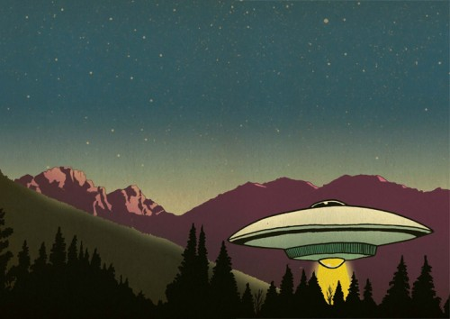
It was twenty-four hours later that Tom woke with a start, though at that point he didn’t realise how much time had passed. He was cold and at first couldn’t remember where he was or what had happened. Beside him, Jez lay curled up. Fast asleep with his thumb stuck in his mouth. Tom stared around him. They were still in the forest and the bushes and grass had been flattened down. Trees were scorched. Of course, the spaceship!
No one believed them and what was worse they couldn’t remember what had happened after the ship’s door had opened. The doctor said that it was amnesia brought on by shock. They both knew that the space ship had landed and an alien had begun to appear but after that, the next 24 hours were a complete blank. In the end, the police went away muttering about time wasters - and left them to get on with the rest of their holiday.
It was only when he went to bed that night that Tom found it. In his pocket there was a jet black pebble. It was shiny and comforting to hold. He rubbed the smooth surface and as he did so, it began to warm and then it glowed. Weirdly, Jez had also found a stone in his pocket. A present perhaps – a present from another world. But what were the stones for? Tom wasn’t too sure if he wanted to know.

