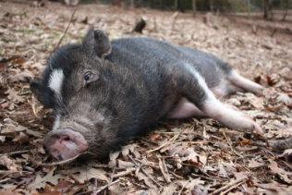
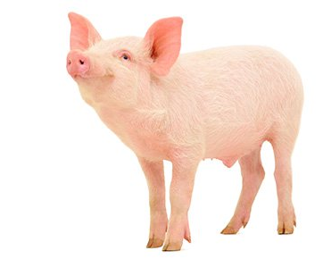
All about Pigs

What do pigs look like?
A typical pig has a large head with a long snout. They have four hoofed toes on each foot. Sometimes pigs are pink but they can also be black with spots. Although people think pigs are dirty animals, they always like to be clean!
Where do pigs live?
Pigs usually build nests to live in. They like to feel warm and cosy at night. They spend hours dragging sticks, leaves and hay into a pile to make a nest.
What is a pig’s diet?
Like humans, pigs are omnivores because they eat both plants and other animals. They use their sensitive snouts to root out food. Pigs will eat almost anything, including bones! However, most of the time they eat leaves, roots, fruits and flowers.
What do pigs like to do?
Most pigs like to swim or have a mud bath. Some pigs like to have a belly rub or play with a ball. Often they like to sunbathe but they have to be careful not to get sunburnt.
Did you know?
All pigs have an excellent sense of smell.
Amazingly, there are around two billion pigs in the world!

