US Today

Deadly dragon on the loose

Yesterday, Louisville, USA, was under attack from a ferocious dragon.
The vicious dragon left a trail of destruction after it scorched the streets with its powerful flames and left claw marks up the sides of many high-rise buildings. Not only that, many people were taken to the nearest hospital after being left with third-degree burns.
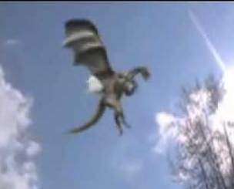

Chris told ‘The US Today’ that he felt very afraid and scared for his life when he was faced with the beast. He said he was feeling petrified about the near death experience. ‘I couldn’t believe what I was seeing in front of me, I thought it was going to gobble me up! I haven’t had an ounce of sleep since this sighting as I fear it may return.’
The city remains under lock-down procedures until the monster has been captured and repairs have been carried out, making the city safe again.

