ESCAPED OCTOPUSES AVOID DINNER DESTINY!

Restaurant owners and customers at Sunnyside Restaurant were distraught yesterday (Thursday 8th August) when their delivery of octopus for their evening dinner service did not arrive. The delivery was their regular Thursday morning booking with Dependable Deliveries, with the octopus coming from Frantic Fishmongers.

At 9am, John Sharp entered the fishmongers to collect the order of one octopus, which the owner assures Sunnytown Daily News was weighed and sold as usual. However, soon after Mr Sharp left the shop, another octopus was discovered missing! Mr Steven Price, the fishmonger owner, told us,
“I didn’t have any customers for a moment, so I went to check that the tanks were all in order. When I stepped out from behind the counter, I slipped over and slid across the shop floor! There was a trail of salty water going from the octopus tank to the door…”
Octopuses live in water so most humans have not seen how they move on land with their eight tentacles, however June Peel, a resident of SunnyTown caught sight of them from the window of her apartment.
“I couldn’t believe it! There were two octopuses, an orange-coloured one and a pinkish-coloured one, travelling across the street. They were being pursued by an Octopus Delivery Van and its driver. No wonder the poor souls were trying to escape! They obviously knew what would happen to them if he caught them!”
Never before has research been carried out to investigate the emotional intelligence of the octopus, but following this unbelievable event, SunnyTown University is considering opening a research position with this focus in mind.
We were unable to talk to Mr John Sharp until late in the day, as he was in hospital. According to witnesses, his van went straight through an apartment and into the sea! He told us,
“I had gone to collect an octopus as part of my collection and delivery shift. I had picked up Sunnyside restaurant’s order and was driving on to deliver it, when suddenly an orange-coloured octopus jumped onto the van – I don’t even know how – and lifted the lid of the box containing the one I had collected! It seemed like a rescue mission, but I couldn’t arrive at the restaurant empty-handed. I trailed them across town and did manage to catch them again, only to be squirted in the eye with their sticky black ink! I lost control of the van because I couldn’t see, and the next thing I knew I was in the sea…”
Who knows where the octopuses are now, but after their eventful escape I would imagine they are relaxing in the glittering oceans, somewhere of the coast SunnyTown. They certainly deserve it.
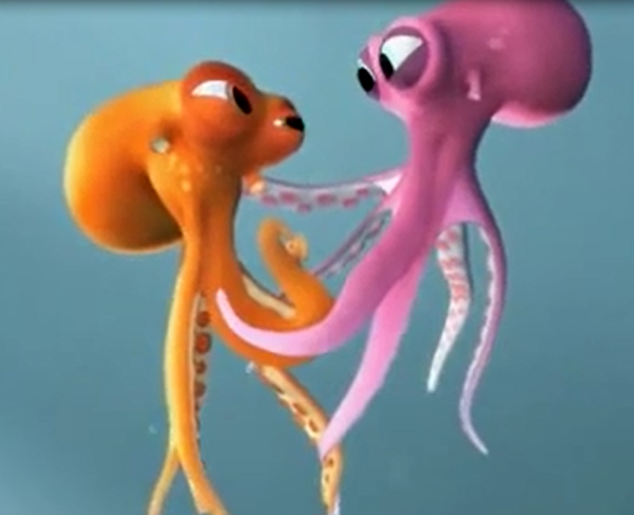
Frantic Fishmongers’ Octopuses escape delivery van!

