How to Make Tissue Paper Poppies
Have you been wondering what to make for Remembrance Day? If so, don’t despair. Help is at hand. Poppies are displayed on this day to remember those who died. They are big, bold blooms that are red and black. Read these instructions and soon you too will have a beautiful flower to use on Remembrance Day.

What you will need:
- One sharp pencil
- A pair of scissors
- A pipe cleaner
- A circular container or template
- Red tissue paper
- Black or brown tissue paper
- White craft glue

What to do:

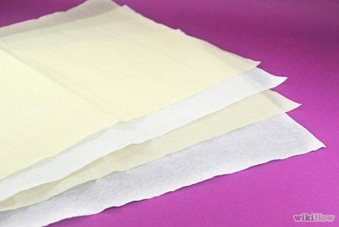 | 1. Lay three pieces of red tissue paper on your work surface. Use additional layers of tissue paper if you want a fuller poppy. Make sure the paper is flat otherwise you will not be able to draw on it. We use red paper because the petals are this colour.
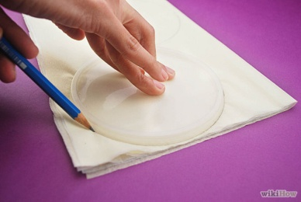 | 2. Secondly, put a round plastic lid, such as a lid from crisp container, on top of the folded tissue paper. Check your pencil is sharp before you begin drawing. Trace around the lid slowly with a pencil. Use scissors to cut out the circle.
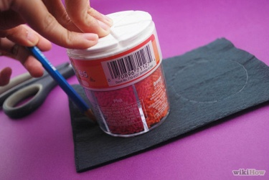 | 3. Next, lay three pieces of black or brown tissue paper on your table. Use a small cup or another object about 5cm in diameter as a pattern. Carefully draw around the circle, then cut out the black tissue paper.
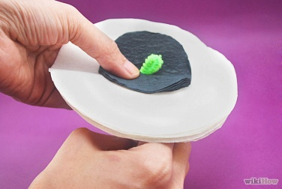 | 4. After that place the stack of small black circles on the centre of the stack of larger circles. Poke a green pipe cleaner up through the middle of the stack while holding the paper firmly. Leave about 2cm of pipe cleaner extending above the paper.
 | 5. Gently bend the pipe cleaner down in a hook shape then pull the bent part of the pipe cleaner through the paper so the hook is hidden in the poppy. Secure the pipe cleaner to the paper poppy with a small amount of white craft glue.
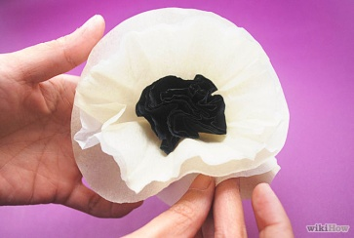 | 6. As soon as the glue is dry, spread the layers of tissue paper to make a ruffled poppy. You mustn’t let the paper become too scrunched because it won’t look like petals anymore.
 | 7. Finally, put a sticker with your name on it at the bottom of the pipe cleaner. Repeat the steps for each tissue paper flower you wish to make.

One final top tip: Tissue paper can rip easily so make sure you handle it with care.

As long as you follow these instructions carefully you will create the perfect poppy!

