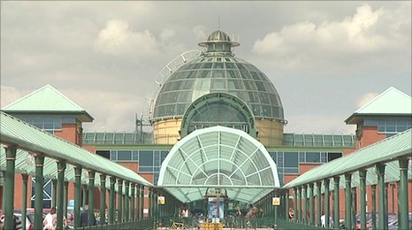
Merry Hill vs Meadowhall
Shopping centres are now at the heart of our everyday lives. We spend increasing amounts of time in these huge buildings, buying anything ranging from our weekly groceries to the most specific of gifts. Two of the largest in the United Kingdom are Merry Hill and Meadowhall, but how do they differ?
Merry Hill (branded now as Intu Merry Hill) is a shopping centre in Brierley Hill near Dudley, West Midlands. It was developed between 1985 and 1990, with several expansion and renovation projects taking place since. Similarly, Meadowhall was built in 1990 and is also an indoor shopping centre. Located in Sheffield, South Yorkshire, England, it lies 3 miles north-east of Sheffield city centre and 2 miles from Rotherham town centre. It is the largest shopping centre in Yorkshire.
Home to over 250 shops, Merry Hill is able to boast a retail park, cinema and an Eat Central food hall including Pizza Express & Nandos with ten thousand car parking spaces. Adjacent to the main shopping site is The Waterfront, which accommodates offices for HM Revenue and Customs amongst others, and has a marina area providing space for a number of bars and restaurants.
Contrastingly, Meadowhall has over 280 stores, most of which are major high street stores, including Debenhams, House of Fraser, Primark and Zara. Fashion labels have their own stores in Meadowhall including Hollister, French Connection and SuperDry. ‘The Lanes’ is an area next to the Oasis Dining Quarter which includes small independent shops.
Recently, Merry Hill has seen some development. The Dudley Canal was re-routed in the late 1990s, and between 2002 and 2005 housing has been developed around the complex. A new line of the Midland Metro tram system was scheduled to reach the site in 2011 but has been delayed indefinitely. Likewise, Meadowhall has improved its transport links in recent years with a revamped bus and train station and new, larger car-parking spaces.
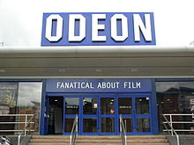
These two retail behemoths are examples of our modern day culture. They both offer a wide variety of shops, a cinema and a place to sit down and have a bite to eat. Meadowhall is the slightly larger of the two but Merry Hill can also boast a far larger cinema and retail park next-door. The question is, where would you rather go?

