ROCK STAR’S SHOPLIFTING SHAME
By Robert Samuel
Crime Correspondent
Ageing rock star, Gary Beast, was arrested in Manchester City Centre yesterday for shoplifting. He was caught red-handed on camera in a well-known Department Store in the Arndale Centre.
The arresting police officer, P.C. Adams, explained that Gary had initially been spotted on CCTV hanging around the make-up counter and behaving in a suspicious manner.
He was caught on camera removing CDs from their boxes and slyly dropping them into a hold-all which he was carrying. When he realised he had been 'spotted' the former singer dropped the hold-all and denied all knowledge of it…and its contents.
The store manager, Paul Newman, said that he was very surprised at what he had witnessed. He stated, “We rarely have any shopping lifting incidents and one involving a famous person is a first!”
This is Gary Beast's third arrest for shoplifting in the past two years. His band 'Bad Breath' split up in 1982 and, since then, Gary has made four disastrous attempts at a musical comeback, each ending in disappointment. As a result, he has fallen on hard times which may go some way towards explaining his behaviour.
When arrested, a visibly upset Gary said, " I don't know what came over me."
The singer admitted taking the CDs but continued, "I don't need any of these. I can't think why I stole my band's entire back catalogue."
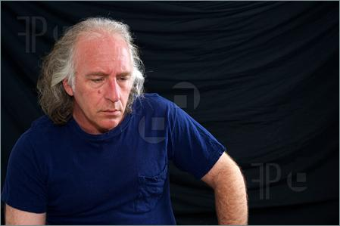
The singer will appear before Manchester Magistrates Court next week to face the charge of shoplifting. If found guilty, he could face two weeks in prison or a £2000 fine.

Gary Beast: Pictured last year at a Yorkshire
music festival.

