MCj01501480000[1]Scurvy

Scurvy is a disease that pirates often suffered from. It is now much less common, with only 100 cases in the UK last year.

[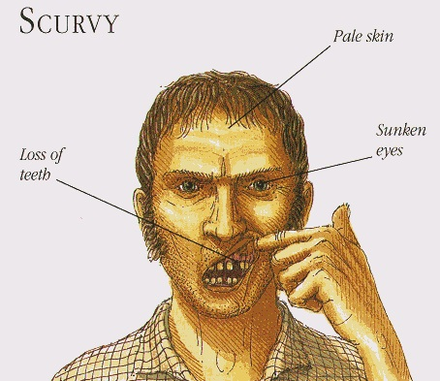](http://www.google.co.uk/url?sa=i&source=images&cd=&cad=rja&uact=8&ved=0CAgQjRw&url=http://www.vitaminsestore.com/scurvy-causes-treatment-symptoms-and-risk-factors/&ei=YHRCVPnQGqjB7Abl_oBo&psig=AFQjCNEzKSCAMZyaHMRQUU5mVnjO0JF6-Q&ust=1413727712502915)What is scurvy?

Scurvy is a condition that causes:

* muscle and joint pain
* fatigue
* red dots on the skin
* loss of teeth
* pale skin
* swollen eyes

Common symptoms of scurvy

[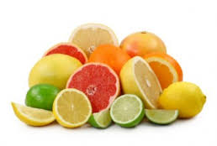](http://www.google.co.uk/url?sa=i&rct=j&q=&esrc=s&source=images&cd=&cad=rja&uact=8&ved=0CAcQjRw&url=http://www.newyorkgirlstyle.com/2011/12/14/vitamin-c-your-secret-vitamin-for-gorgeous-skin/&ei=RXVCVLizD820adnhgZgH&bvm=bv.77648437,d.d2s&psig=AFQjCNHY_fwCliiJxPvvzhw0bswN-N-kkw&ust=1413727921427308)What causes it?

Scurvy is caused by a deficiency vitamin C. This is when you don’t have enough vitamin C in your diet. Vitamin C can be found in many fresh fruits like oranges, lemons, limes, grapefruit and cantaloupes, and in vegetables such as bean sprouts, green peppers and broccoli.

Sources of vitamin C

Who does it affect?

In the past, scurvy was common among sailors and other people who couldn’t eat fresh fruits and vegetables for long periods of time. However, scurvy can still affect elderly people or those on a low income.

MCj01501480000[1]Scurvy (LA)

Scurvy is a disease that pirates often suffered from. It is now much less common, with only 100 cases in the UK last year.

[](http://www.google.co.uk/url?sa=i&source=images&cd=&cad=rja&uact=8&ved=0CAgQjRw&url=http://www.vitaminsestore.com/scurvy-causes-treatment-symptoms-and-risk-factors/&ei=YHRCVPnQGqjB7Abl_oBo&psig=AFQjCNEzKSCAMZyaHMRQUU5mVnjO0JF6-Q&ust=1413727712502915)What is scurvy?

Scurvy is a condition that causes:

* muscle and joint pain
* tiredness
* red dots on the skin
* loss of teeth
* pale skin
* swollen eyes

Common symptoms of scurvy

[](http://www.google.co.uk/url?sa=i&rct=j&q=&esrc=s&source=images&cd=&cad=rja&uact=8&ved=0CAcQjRw&url=http://www.newyorkgirlstyle.com/2011/12/14/vitamin-c-your-secret-vitamin-for-gorgeous-skin/&ei=RXVCVLizD820adnhgZgH&bvm=bv.77648437,d.d2s&psig=AFQjCNHY_fwCliiJxPvvzhw0bswN-N-kkw&ust=1413727921427308)What causes it?

Scurvy is caused a lack of vitamin C in your diet. Vitamin C can be found in many fresh fruits like oranges, lemons, limes, grapefruit and cantaloupes, and in vegetables such as bean sprouts, green peppers and broccoli.

Sources of vitamin C

Who does it affect?

In the past, scurvy was common among sailors and other people who couldn’t eat fresh fruits and vegetables for long periods of time. However, scurvy can still affect elderly people or those who don’t have much money.