The Athenian News
20th June
Prominent local heiress flees tyrannical father
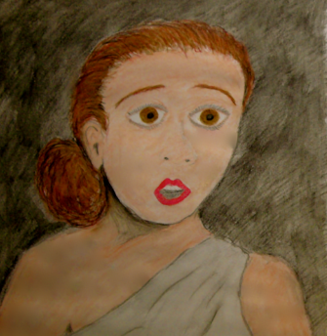  Hermia, yesterday afternoon, vowing to marry Lysander. | by I.M.A. Writer | Meanwhile, preparations continue for the wedding of the year. Mountains of food have been brought into the city, and huge vats of ice have arrived to keep the food fresh. International chefs have warned people to keep their windows shut over the next 24 hours, as the enticing, mouth-watering smells could drive them totally insane. Local food critic, Ima Gourmand, who writes for this paper at the weekends, was consumed by excitement when we spoke to her.  “Hermia is a silly, silly chit,” she warbled, as she tasted one chef’s Poulet au Truffes de montagne. “With food like this around, she should have waited until after the wedding, then eloped!”  The renowned couturier, Madame de Pomade is said to be furious at the slight to her dressmaking skills, as Hermia has abandoned the specially designed and sews dress that was ordered from the internationally famous seamstress. "Who is going to wear my magnificent creation now?” she asked haughtily.
not prepared to make allowances for me.
The news of her elopement was broken to her fiancé by Helena, a close friend of Hermia’s since they were at primary school together.
“I didn’t think that she really intended to go through with the elopement,” she wept, as she brought the news to Demetrius. “I tried everything I could to convince her to do the right thing, but she simply would not listen.”
Friends of the two girls are not sure that Helena was an unbiased party to the disappearance, as it has long been known that she has a ‘thing’ for Demetrius herself, and was not seen for several weeks after the engagement of Hermia and Demetrius was made public at the beginning of June, preferring to confine herself to her rooms in her father’s palace near the Parthenon.
“I wouldn’t be surprised if she had given the idea to Hermia, in order to keep Demetrius for herself,” one friend was heard to say when she heard about the morning’s shenanigans.
Demetrius, the most eligible bachelor in Athens – after Duke Theseus, whose marriage to Queen Hippolyta is set to happen tomorrow at dawn – was seen galloping into the woods around the city, in pursuit of the two lovers. He cut a fine figure on his latest acquisition, a fine pure blood Arab steed named Diablo, which has already won a number of local races.
There was much consternation in Athens earlier today, as the whereabouts of Hermia, daughter of Aegeus remained unknown.
Hermia (engaged to Demetrius from birth) enraged the local nobility last week, when she decided to renege on the arrangement, in order to marry another nobleman’s son, Lysander.
After yesterday’s visit to the court of Theseus, king of Athens - in which she was given a day to choose between obedience to her father’s wishes and a life in a nunnery - Hermia vowed to throw up her expensive lifestyle of luxury and flee with her true love, to a small temple in the forest, there to be wed by the local woodland priestess.
“I cannot live without Lysander,” she claimed, frantically packing a few necessities into a small carry-all. “I plan to marry even though I understand that it will mean exile and banishment for the rest of my life. I love my father dearly, but in this situation, I cannot obey him, and do not understand why he is
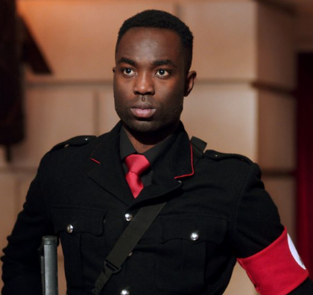
Demetrius does not understand why Hermia has turned down his offer of matrimony.

