On Thursday 13th October 1876, a Highwayman was finally brought to his death with a clever plan carried out by King George’s Men. Robbery, theft and gun crimes resulted in the Highwayman being wanted. The incident occurred at Hounslow Heath at moonlight. It is believed he was shot then fell to his death upon the highway, a fitting end for this conniving villain.

Earlier this week, the Highwayman went to the old Inn yard where he met Bess - who is the landlord’s daughter. Here he told Bess that he would come back after moonlight to find her. However, Tim, who is an ostler at the Inn, overheard him talking to Bess and he felt it was his duty to inform King ​George’s troops of the Highwayman’s location.

King George’s men then came up with a clever plan for catching the Highwayman. At moonlight, the Highwayman rode back to find Bess only to discover her with her head over the musket - drenched with her own red blood! Suddenly, in a state of shock the Highwayman spurred to the west brandishing his rapier. Only for King George’s men sho0t him down on the highway - down like a dog on the highway,

John Johnson who witnessed the event described it as a seamless and well executed plan. When speaking to the reporter he said “All I could hear was muskets going off in every direction and shirking everywhere. Eventually, I realised what was happening and I took cover in the bushes. I am just glad the Highwayman has been shot and we can travel a little bit safer now.’
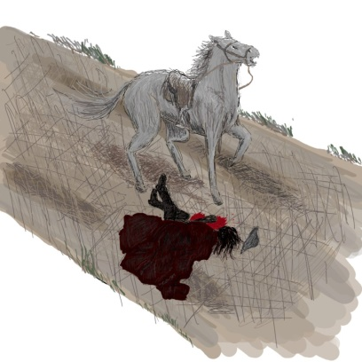

Highwayman down dead on the highway after being shot be King George’s

With the hated Highwayman dead we can all travel more safely on the roads. Presently, travellers are still advised to take ​care and not journey ​alone on the highway.

