The Romans

The Roman Army
Because they had such a good army, the Romans invaded many different countries. The army was used to protect Rome and to keep control over the people who they had conquered. While they were in the army, the soldiers had to spend a lot of time away from their families. Since they had to march over 20 miles a day with heavy items to carry, the soldiers had to be extremely strong and tough. They had to carry their food, cooking pots, tents and weapons as well as wearing all their armour. The Roman soldier was very well trained. When their enemies fired their arrows they would put their shields up all around them to protect themselves from the arrows, this was called the tortoise. They used a short sword as a weapon, daggers for stabbing and a long spear. They wore metal armour and protected themselves with a large shield.

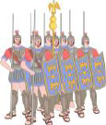
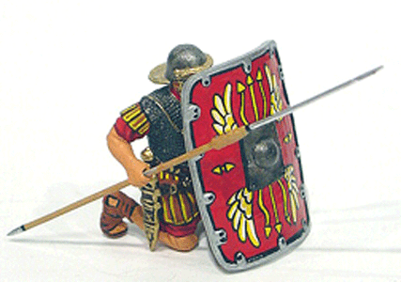

Roman Life
In Roman times most children did not go to school. Because it wasn’t free, parents had to pay for their child’s education. Therefore, only rich children went to school. Poor children learnt a trade from their fathers as they could not afford their education. Boys would learn the jobs that their fathers did like being a baker or a metalworker. Girls were taught household skills like weaving, spinning, sewing and cooking from their mothers
For the Romans, men and women weren’t equal. If you were a male, you could do any job which you wanted, including becoming an emperor. However, women were kept busy looking after their families and homes.

Roman Villas
Villas were originally built as houses for wealthy Romans in Italy. When they invaded Britain, some of the Romans started to build them here too. These villas were like country mansions today. They had exquisite living areas with mosaic tiled floors and luxury gardens planted with trees and shrubs. The insides of the villas were beautifully decorated- the floors in these homes would also have been kept warm, as the Romans had their own design of heating underneath the floor. This was similar to the central heating which we have in our homes today. The floors were laid on top of columns so that warm air from a furnace could be pumped into the spaces underneath.
Remains of an underfloor heating system. 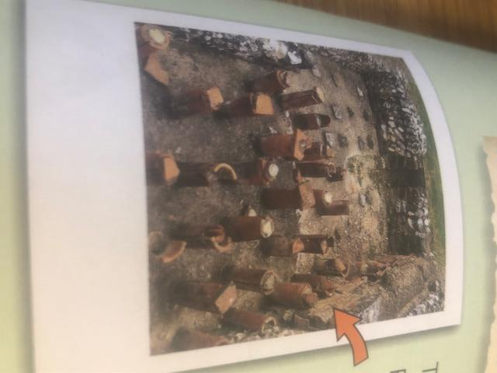

Roman Baths
Romans liked to bathe a lot, they considered themselves very clean people and they build splendid bath houses. They did not only go to the public baths to get clean but also to meet with friends and exercise. There were also places to eat, rest, play games and read at the baths. The public baths were not free and people had to pay to go there but it was quite cheap. Men and Women bathed in separate baths. There were baths in every town in the Roman Empire. Since they were rich, the villa owners would have their own baths in their homes. The Roman baths were very cleverly made as they always had to have a constant supply of water. The water was either piped in or brought to the town by an aqueduct. In some places like Bath in Somerset a natural spring would provide the bath with its water. Water was heated by the central heating system similar to the ones Romans used in their homes, this was called a hypocaust system. There were three parts to a Roman bath the cold bath called the frigidarium, the warm bath called the tepidarium and the hot bath called the caldarium. In order to get clean, the Romans would use the hot room and a slave would rub sweet oil on them and scrape it off with an instrument called strigil which looked like a knife but did not have a sharp blade.
A strigil used to scrape the oil off the body

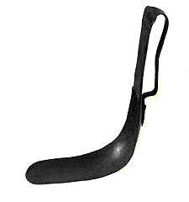

Roman Roads
Travellers in Britain had plodded along trackways long before the Romans came. Because they needed paved roads to carry heavy wagons and marching troops, the Romans built highways and soon they had built a network of roads across Britain. Roads between the main settlements had forts along them for army use, but most routes were built for trade and to link towns. Roman roads were usually built straight. Because heavy wagons were hard to pull uphill, mountain roads were made in a zig-zag across the slope to make the climb less steep.

Roman Towns
The Romans built Britain's first towns. Within 17 years of the invasion of Britain, they had several major towns in place connected by the famous Roman roads. Towns soon became important places for meetings and trade. The Roman towns were full of fine buildings and temples.
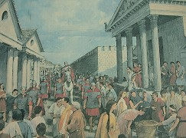
Each town had two main roads. One heading North-South and the other East-West. At the point where these roads met was the town centre.
Every town with a name ending in 'chester' or 'caster' or ' cester' was once a Roman town e.g. Doncaster, Manchester and Leicester.

