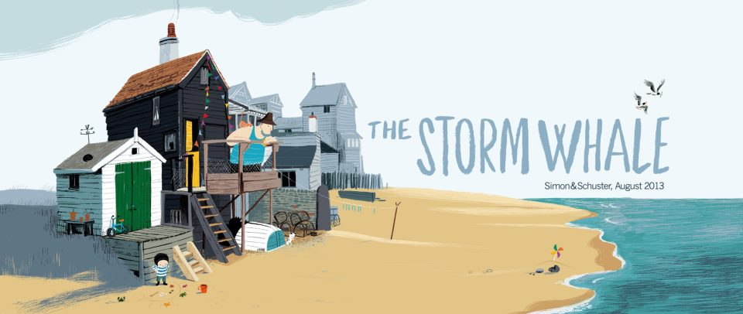

Noi lived with his dad and six cats by the sea. Every day, Noi’s dad left early for a long day’s work on his fishing boat. Unfortunately, it was always dark when he came home and he didn’t have any time to spend with Noi.

One night, a great storm had raged around their house. In the morning, Noi went down to the beach to see what interesting things had been left behind. As he walked along the shore, he spotted something in the distance. Closer and closer and closer he ran until… He couldn’t believe his eyes! It was a little whale washed up on the sand.

Noi wondered what he should do next. He knew it wasn’t good for a whale to be out of the sea. Then Noi had an idea. He placed the storm whale on his trolley and pulled, pulled, pulled it all the way home. Eventually, he put the whale in his bath and even told it stories about life on the island - the whale was an excellent listener.

The night was drawing in and it was getting dark. Noi was worried that his dad would be angry about having the whale in the bath. Somehow, he managed to keep his secret safe all evening. He even managed to sneak some food for the whale.

Suddenly, Noi heard a STOMP, STOMP, STOMP! Dad walked into the bathroom. Thankfully, he wasn’t angry. Dad had been so busy, he hadn’t noticed that Noi was lonely. Together, they rowed out to sea in the lashing rain to return the whale. Noi felt sad but it was the right thing to do.

Noi often thought about the storm whale and he hoped that, one day soon, he would see his friend again… and HE DID, splashing in the sea! He was safe and sound with his family.

