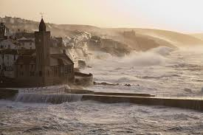
Howling through the streets like a banshee, the invisible enemy pummels the windows and shrieks down the chimneys. Rolling dustbins clatter down the cobbled streets, leaving a trail of whirling, debris in their wake, while the squat houses crouch against the cliff side, bracing themselves against the onslaught of the gale, their doors and windows firmly locked.
Far below, the angry sea explodes against the cliffs, the water boiling and heaving; swelling and surging, whipped up by the force of the storm. Down in the harbour, the fishing boats tug angrily at their moorings, the ropes on their masts chattering angrily. Over the noise of the wind, the sound of the church bell can be heard tolling erratically as the gale gusts through the bell tower.

1. What do you think a banshee might be? What makes you think this?
2. What kind of noise do you think it might make? Give reasons for your choice.
3. What is ‘the invisible enemy’? Why has the author used this phrase?
4. How is a contrast made between the dustbins and the houses?
5. What words are used to describe the sea? Why have these words been chosen?
6. Can you find examples of personification in the text?

TASK: Change the sentence beginning “Far below….” To describe the sea on a calm summer’s day.

