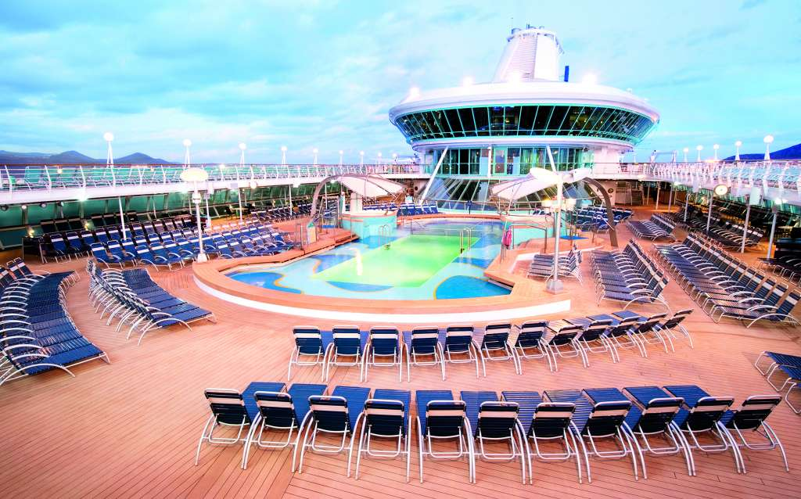  Why go on holiday to just one country? With Thomson Cruises you can visit all wonders of the world and set sail in style with all-inclusive 5 STAR accommodation and outstanding service. Choose from a range of worldwide tours suitable for all the family or select from one of our adult-only sailings and set sail as king and queen!  From the moment you board you will never want to leave. The adventure of a lifetime is just waiting for you!  Don’t delay - BOOK TODAY!  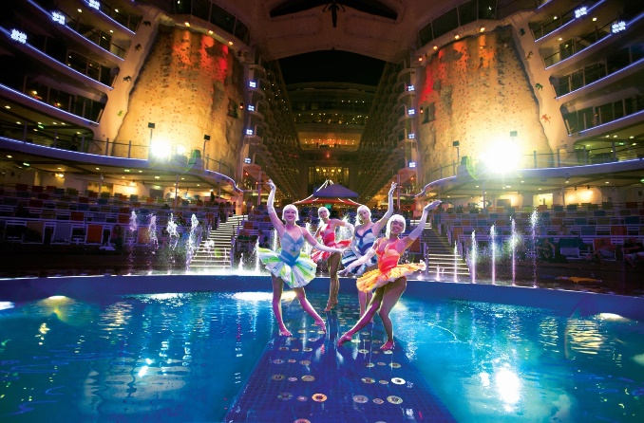 | Service with a smile!  (All prices include tips and surcharges)  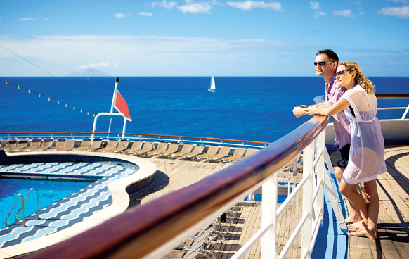  All of our cruises come equipped with staff to accommodate your every need. When you book with Thomson you’re booking the chance to try tonnes of new experiences! Our ships have sport decks with table tennis and basketball tournaments daily. Morning fitness classes, dance classes, quizzes, games shows and cookery demonstrations will keep you entertained between destinations. After sundown, we set the scene for some superb entertainment in our plush show lounges. Sing along to the West End’s finest musicals or be audience to UK stand-up comedians, which will be sure to have you laughing ‘til your sides ache! | All of our ships have at least 3 restaurants and our chefs will take your taste buds around the world at one of our self-service buffets. Or you can sit down to a multi-course dinner in a more formal setting where it’s all about waiter service from suited and booted staff. Don’t worry if you’re feeling peckish between meals you can choose from snacks on deck to afternoon tea and midnight buffets.  You’ll never go hungry!  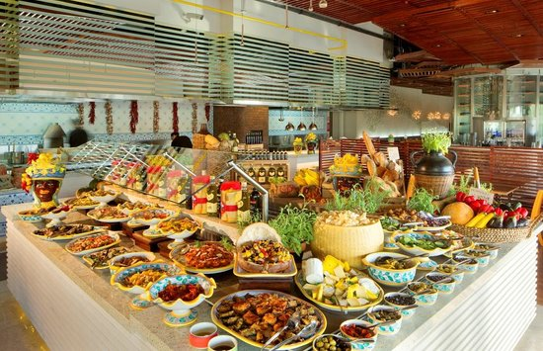  Visit – www.thomson.co.uk/cruises for more information and our latest deals!

