Outdoor Games
Many adults and children enjoy playing outdoor games. There are many different games you can play with, such as, cricket bats, super soakers, skateboards and many more.
Skateboards
A skateboard is a wooden board with four wheels which you balance on. Many people enjoy the fact that skateboards can go fast and riders can perform tricks on them.

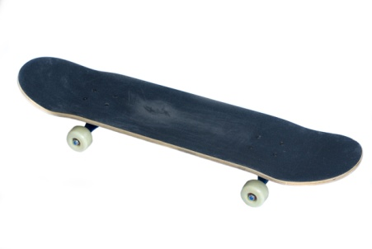
Super Soakers
Super soakers can spray water a long way and at great speed. They work by pumping the water from a pistol’s tank. They are also made from plastic.
