

Brimington News

*Trumpeting the news of BJS – January 2018 (50p)*

Viking invasion in Brimington

**VICIOUS Vikings have invaded Brimington.**

The attack happened in the early hours of Sunday night when over a 100 of the pillaging Norse invaders descended on the sleepy hamlet in Mercia.

The alarm was raised at 2am on Sunday in the north of the village. Shortly after 2:15am, the Vikings had already attacked half the houses, leaving a trail of death and destruction. By 3am, the whole of Brimington had been targeted.

In the aftermath of the tragic incident, there were plumes of smoke ascending from homes set ablaze by the Vikings. Agonisingly, cries of distress for missing or dead loved ones could be also heard across the Saxon settlement.

Eyewitnesses describe scenes of chaos and carnage as the invaders went from house to house pillaging and killing indiscriminately.

One survivor stated, “It was horrible. They burned our house down. I was lucky to escape. It was all so sudden. We had no idea they were coming. We had heard tales from up north of attacks but we never thought it would happen in our village. We are devastated.”

It is believed that more than 80 people have been killed. However, there are further reports that another 25 people are unaccounted for and may have been captured by the Vikings and taken back across the Great Sea to be used as slaves.

Viking expert Aldin the wise one said, “It is likely the Vikings will return – and with greater numbers. My advice is to leave the area as soon as possible and head south.”

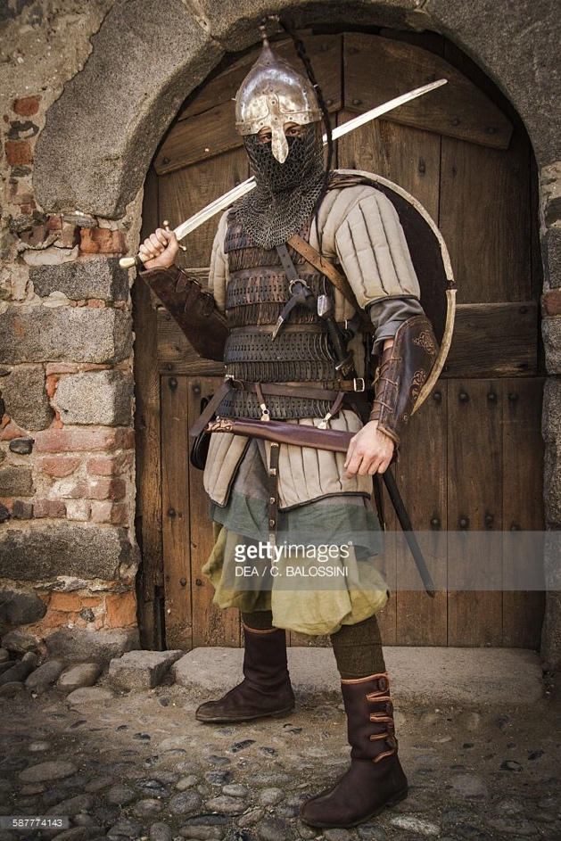

* *Pictured above is an artist’s impression of one of the Viking invaders who have terrorised Brimington.*

**Traumatised by the Viking attack? Then this is for you. A special tonic made up of cow dung, sheep’s urine and a healthy dose of chicken liver. The perfect pick-me-up, guaranteed to make you sleep better. Not convinced? Read this testimonial:. “Them ‘orrible Vikings took everything from me. I’ve got nothing left. But one swig of this potion and I was right as rain feeling like a new born babe. Ahhhhh, that’s good.” Special 2 for 1 offer. Just bring in a copy of the newspaper to claim your tonic.**