Cats
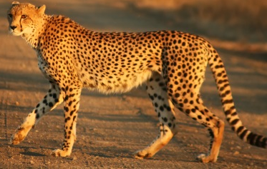
There are lots of species of cat. They are a predator and a mammal. There are domestic cats, which live with people, and wild cats, that live in the wild.
Cheetah
The cheetah is characterised by a slender body, deep chest, spotted coat, a small rounded head, black tear-like streaks on the face, long thin legs and a long spotted tail. Though taller than the leopard, it is notably smaller than the lion. They are basically yellowish tan or rufous and the coat is uniformly covered with nearly 2,000 solid black spots.
The cheetah inhabits a variety of habitats; such as prairies, jungles and deserts.
Cheetahs are active mainly during the day, with hunting their major activity. They eat small antelope and the young of some larger animals, such as warthog, kudu, hartebeest, oryx, roan and sable; as well as game birds and rabbits. They have a high-pitched howl and purr like a house cat. They can run 60-90km per hour. It is the fastest animal in the entire world.
Lion
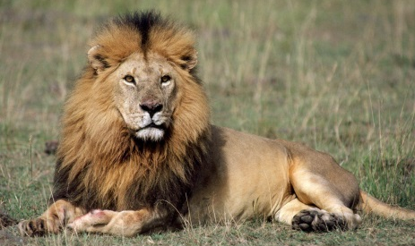
Living in the grasslands, scrub, and open woodlands of Africa, the lion is the second largest cat in the world. It is dwarfed slightly by the tiger, which is closely related and has a very similar body type.
Males are taller and heavier than females and display a mane of long hair around their face (in fact, it is the only case in the feline world where males and females actually look different).
Unlike other cats, lions are very social animals. They live in groups, called prides, of around 30 lions. The size of the pride is determined by the availability of food and water. If resources are scarce, the pride becomes smaller. Lions usually hunt at night. Their prey includes antelopes, buffaloes, zebras, young elephants, rhinos, hippos, wild hogs, crocodiles and giraffes. But they also sometimes eat smaller prey like mice, birds, hares, lizards, and tortoises. They are not above stealing kills from other carnivores, like hyenas, wild dogs, cheetahs, and leopards, or scavenging spoiled meat.
Puma
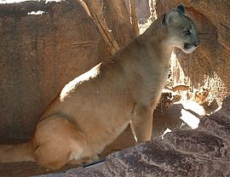
Pumas (also called cougars or mountain lions) are large wild cats that live on the west coast of Canada, in the western half of the United States, and most of Central and South America.
They are mainly tan-coloured, and can be up to 9 feet long, although the average length is 6 – 8 feet. They can weigh from 29 kilograms to 90 kilograms.
Pumas are carnivores because they eat only meat. They hunt deer, raccoons, squirrels, foxes, rabbits and skunks. They can also eat mice, beavers, coyotes, birds and porcupines. They hunt at night. Pumas can see better at night than people can. They live and hunt alone. Female pumas take care of their cubs until they are old enough to fend for themselves.

