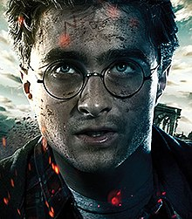

Clever Harry Potter never liked to be defeated; he always rose to the non-stop magical or deadly challenges that were thrown his way. Due to his flexibility, quick thinking and bravery, he was a talented quidditch player and his hiding skills weren’t too bad either. After a lot of practise, he became the king of magic spells and could use this to his advantage in many life-threatening situations. He was underestimated! Because he was so loving and gentle, he was often naïve to the evilness at Hogwarts, but he never let his bad luck spoil his good nature. He was recognised by everybody. You couldn’t miss the glaring lightning bolt stamped on his young forehead or his distinguishable stare. Round glasses hung in front of his glossy blue eyes which glowed with a mixture of determination, sorrow and confusion. His once quivering hands turned to steel over time and it was rare to see him without his pointed, life-saving wand or a jet-black cape. Although he had a relatively ordinary appearance, he was far from ordinary! Harry Potter was the kind of wizard that you could meet once but never forget!

