How to care for a cat.
Do you have a pet cat? Are you unsure how to look after them? If so, read these detailed instructions and follow them carefully and hopefully you will have a happy and healthy cat.

What you will need:
- Cat food
- Water
- food bowl
- Water bowl
- Collar (with name tag)
- Scratching post
- Cat specific toy
- Cat comb
- bedding
Instructions:
- When your cat first arrives in your home, put out cat bed in a quiet, spacious place. Make sure that the bed is big enough to hold your cat. They may not sleep in the bed on the first night but your cat will eventually enjoy sleeping in their beds.

- During the first night, carefully fill the food bowl with cat food. Be warned, cats should not eat chocolate as it is poisonous to them. Some fussy cats will only eat wet food, where as some will only eat dry food. You may need to give your cat a range of food to find out what they like to eat. Unfortunately, every cat is different.

- Pour fresh water into the water bowl and place gently next to the food bowl. You must change the water every day and ensure that you top up the water when necessary.

- Gently, tie a collar around your cat’s neck. The collar will need a tag with your name and address on so that, if your cat gets lost, it can be reunited with you and your family. Be warned, your cat may bite and scratch during this process.

- Cats enjoy regularly scratching their claws along a rough surface. Place a scratching post in your house for your cat to use.

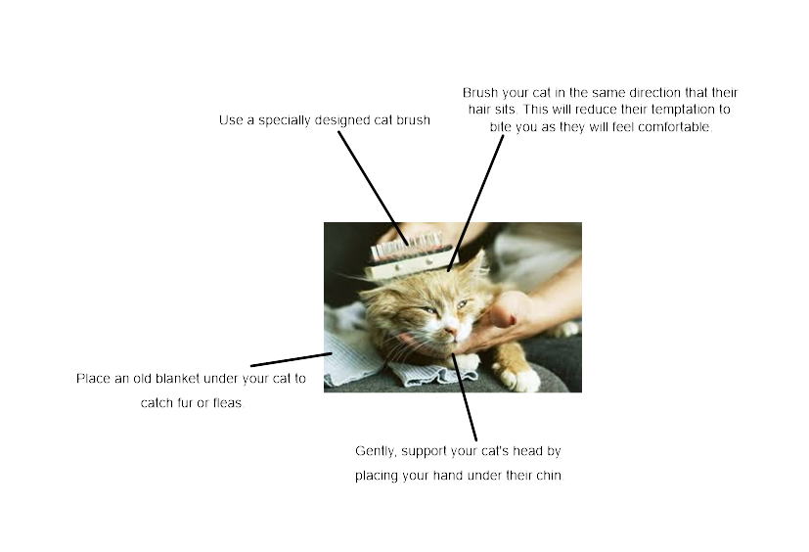
- Finally, cats can catch fleas when they spend time outside. Therefore, it is important to brush their fur (in the same way that we wash and brush our hair) at least once a week with a specially designed brush. These can be found online or in pet shops. The diagram below shows how to correctly brush your cat.

