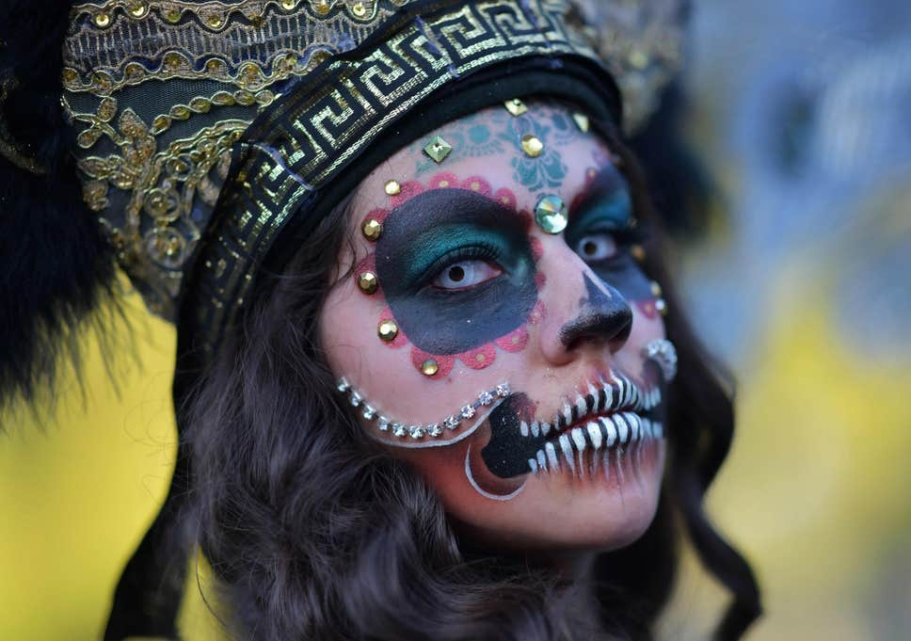
Mexico:
Day of the Dead
El die de los Muertos stands for ‘The day of the Dead’ and is a Mexican celebration in which the dead are honoured. It is a happy occasion full of rejoicing and sharing memories.
When
The Day of the Dead is celebrated across 3 days. The three days are full of fiestas, flowers, food, candles, parades, prayer and fun. The first day is on the same day as Halloween, 31st October. On this day at midnight, the gates of heaven are opened. The second day, 1st November, is when the spirits of deceased children (angelitos) visit. The third day, 2nd November, is when the spirits of adults visit.

Where
Most commonly The Day of the Dead is celebrated across Mexico however, it is also celebrated in areas of North America, such as California and Texas, where the Mexican/American heritage exists. Day of the Dead is celebrated in Mexico, Ecuador, Guatemala and other areas in Central and South America, specifically those with the Latino ethnic background.
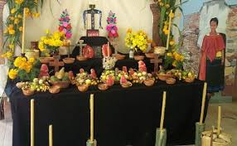
Altars – Ofrendas
People create ofrendas (altars) to honour the deceased. The altars are a space to remember loved ones and light candles to guide the spirits.
The altars include:
pictures of the deceased
items they were fond of
something to eat
candles
flowers
gifts

Food amd Pan de Muertos – Bread of the Dead
Foods that the deceased enjoyed whilst alive are placed on the alta. The dead have come back to visit when the food has spoilt. Fizzy drinks go flat, bread becomes hard and fruit softens. A special Day of the Dead bread called Pan de Muertos is eaten. This bread represents the soul of the departed. The loaves are sometimes baked in the shape of skulls and sometimes are round loaves decorated with bones. The bread is often decorated with frosting or seeds, which represent happiness in some areas of Mexico.
Did you know
Sometimes parades are held where people dress up as skeletons and wear elaborate costumes and masks. The masks represent becoming another person or another being – alive or dead.

Flowers
Flowers adorn altars, crosses, costumes and grave sites. Orange and yellow marigolds are symbolic of life whilst ruby coxcombs are used as enticement for the returning spirits. The sweet smell of the flowers guide the souls back to their homes and altars.
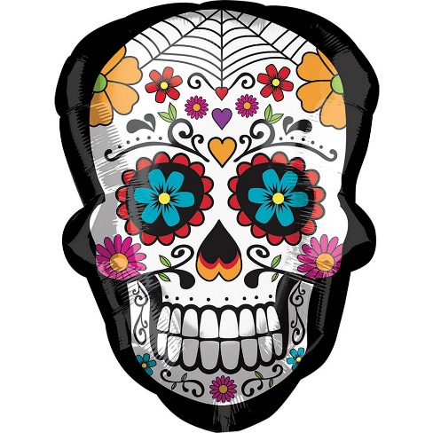
Skeletons – Calacas
Skeletons are a constant emblem during Day of the Dead. Not only are skeletons seen in decorations but also in sugar skulls, chocolate skulls, figurines and toys. These skull toys and figurines are called calacas and are used to introduce children to the idea of death so that they are not afraid of it. Often, the calacas are grinning because they are laughing at death. The calacas show an active and joyful afterlife often depicted as musicians, brides or on horseback.

Candles – Las Velas
Candles (las velas) are lit during the afternoon at altars and grave sites to burn all evening. The light of the candles guides the way for souls. Sometimes each candle lit represents a departed soul. The candles are placed in the four cardinal points to make a cross. Certain coloured candles have meanings:
• purple – pain
• white – hope
• pink – celebration

