GIANT PANDAS
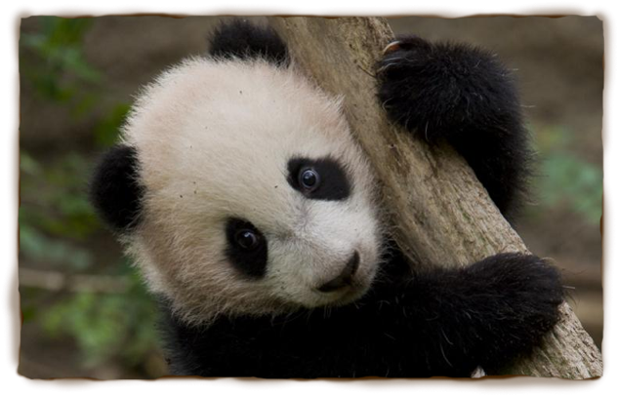
Pandas are mammals, native to China where they are considered a national treasure. Being mammals, the females are able to produce milk to nurse their young. As with most mammals, Pandas have fur or hair on their bodies. The Giant Panda, which is known by other names including: parti-coloured bear, bamboo bear and the great panda, is easily distinguished from its distant cousin the red panda due to its large size and black-and-white coloured markings. It is thought that the bold colouring of the Giant Panda (Ailuropoda melanoleuca) may provide camouflage.
Habitats
In the wild, Giant Pandas are only found in the remote mountainous regions of central China, as this is where the cool bamboo forests that are perfect for the giant panda’s needs are located. Giant pandas make their dens from hollowed-out logs or stumps of conifer trees found within the forest.
In captivity, the Panda’s natural habitat is modelled using man-made structures and careful planting of bamboo, indigenous to China. However, the artificial version never quite matches up to the real environment in which Giant Pandas live in the wild.
Diet
Pandas are very fussy eaters. Giant pandas only eat bamboo - which is a type of grass that grows in the mountainous areas of China – whereas their cousin, the red panda has a varied diet consisting of nuts and seeds, Giant pandas need to eat for 12 hours a day in order to consume vast quantities of bamboo 28lbs/12.5 kg, thereby providing them with the necessary nutritients in order to survive. The giant panda’s stomach is ideal for digesting bamboo as the walls of the stomach are extra-muscular to digest the wood of the bamboo. The stomach is also covered inside with mucus that prevents it from being punctured by splinters.
Habits
Giant pandas are loners. They dislike being around other pandas so much that they have a heightened sense of smell that lets them know when another panda is nearby so it can be avoided. If another giant panda does get close, the two will end up swatting and growling at each other. Sometimes they will even bite each other.
Did you know?
- Pandas have an extra digit on their hands, which helps them to tear the bamboo.
- The Giant Panda does not hibernate but will shelter in caves or trees in very cold weather.

There are not many pandas left in the wild and they are a symbol for animal conservation all around the world. Many zoos and wildlife parks are trying to breed more pandas to save them from extinction.

