Parts of a Plant
There are many different types of plants in the world, but most are made up of the same parts.
Roots
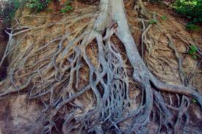
The roots are at the bottom of the plant, underneath the ground. They anchor it into the soil and keep it in place. Nutrients and water enter the roots from the soil to feed the plant.
The roots of a tree

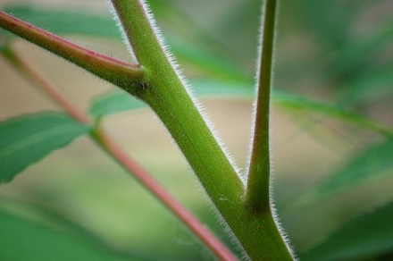
Stem
The stem holds up the plant. When the nutrients and water enter the plant, they travel up through the stem.
The stem of a flower
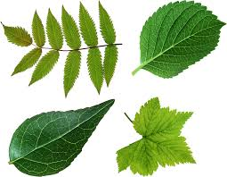
Leaves
A plant’s leaves are very clever. They take in light from the sun and use it to make food for the plant.
Some different leaves

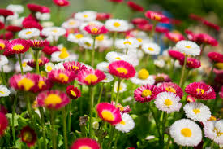
Flower
The flower makes seeds that can grow new plants. Insects are attracted to the flower because it is bright and colourful.
Flowers growing in a meadow.

