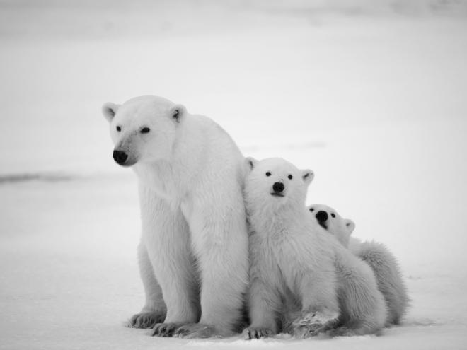
Polar Bears
Have you ever wondered about polar bears? If so, this report will tell you everything you need to know. Polar bears are the kings of the Artic. Read on to find out more.
Where do Polar Bears live?
Polar bears live in countries around the Arctic: Canada, Russia, the United States, Greenland and Norway. In the winter, temperatures in the Arctic are usually around minus 29 degrees. In the summer, polar bears live on the land. In the winter they live on the ice.
A polar bear and its cubs.
What do Polar Bears do?
Polar bears are solitary which means they spend most of their life alone. The animal will spend its days wandering across the land or swimming in the Artic sea, stalking its prey or napping in shrubs or snow dens. When a polar bear swims under water it closes its nostrils so no water can get in. Polar bears are excellent swimmers because they use their big front feet to paddle and their back legs to steer.
What do Polar Bears look like?
Polar bears are well-equipped for survival in a harsh, cold environment. They have two coats of fur and a thick layer of blubber to help insulate the polar bear's body from the cold. Also, polar bears have wide, large paws which help them to walk in the snow. Their claws help them to catch their prey and to dig out snow dens in the winter. Their fur is white to help them camouflage in the snow, although their skin is actually black underneath.
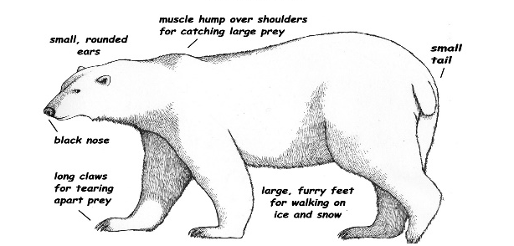
.

A polar bear’s body.

What do Polar Bears eat?
Polar bears are carnivores so they eat only meat. They feed mainly on seals but they may also eat walruses or dead whales and narwhals. They will wait patiently by a hole in the ice until a seal comes up to the surface to breathe before they attack it. They have a great sense of smell which they use to find their prey and then they use their sharp claws to catch and tear it up to eat. In addition, they are also excellent swimmers which helps them to hunt too.
Did you know?
Polar bears are the largest carnivores that lives on land.

