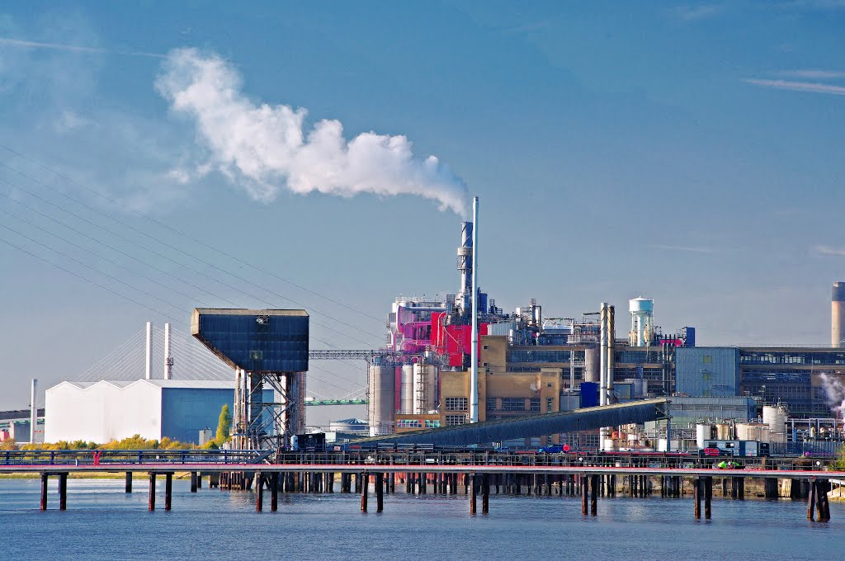

Proctor and Gamble Polluting the air.

**Dangerous Pollution in YOUR Area!**

**The Daily Thurrock News**

**Friday 8th December**

In addition, air pollution can also affect our breathing, lungs and people’s asthma. Can you imagine not being able to breathe whilst outside? That is the situation for 250, 000 asthmatics who live in our polluted towns and cities.

Also, air pollution can affect plants and animals. If plants take in polluted air, eventually they will die which will mean there is no food for animals and humans.

In the future, we all need to work together to reduce air pollution. You could use your car less, why not take a bike on short journeys?

Most importantly, join the campaign to force Proctor and Gamble to reduce their air polluting emissions.

For more information visit: [www.pandgreduce.co.uk](http://www.pandgreduce.co.uk)

By Class 16

**Thurrock is one of the most polluted towns in UK and P and G is one of the** biggest contributors.

and P and G is one of the biggest contributors.

**the biggest contributors. When will P and G stop making so much pollution? The** more pollution they make the more people will suffer as a result

**Pollution? The more they make, the more people will suffer as a result.**

Proctor and Gamble are emitting a million micrograms of air pollution per cubic metre every month. Compare this to the city of Bristol, where only 100 micrograms of air pollution have been measured.

Air pollution has many different effects, on both humans and nature. A study, carried out by Oxford University found that babies born in cities weighed at least 5 grams less than those born in less polluted areas.