STAFF SHOCKED AT SLIMEY SURPRISE

The staff at Broadmeadow Junior School have been left in a state of shock after unexplained slime was found all over their school.
The slime, which is the consistency of glue and smells like acid and paint, has been found in every single classroom although the majority was discovered outside on the playground. Rumours have begun to circulate between parents and children, with many believing that this slime is from another planet.
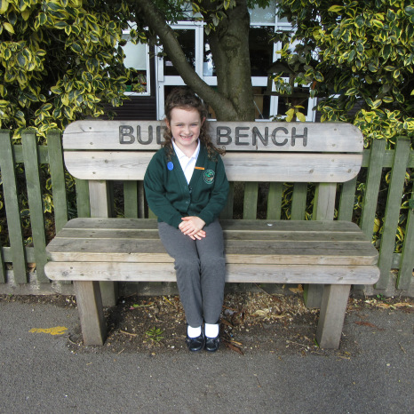
Children at the school have been kept away from this unexplained goo whilst police officers and detectives have investigated. “We have never seen anything like this,” one officer confessed, “and to be honest, it has left us completely clueless.”
The head teacher at the school, Mrs Gaynor, has supported police in asking anyone with any information to contact the school immediately.

By Joe Jackson
On Monday 12th March 2018 at approximately 7am, teachers at Broadmeadow Junior School discovered a large quantity of revolting, green-coloured slime spread around their classrooms, school hall and playground. The slime was discovered when the school was reopened after the weekend but nobody knows where it has come from or why it is there.
Mr Henry, the site manager, was the first to discover this slime when he noticed some covering the alarm panel in the school’s entrance hall. “I thought it was just mess left from one of the classes,” Mr Henry explained to our reporter. However, upon closer inspection of the school grounds he realised that this could not be the case.
Everything was normal when the school was locked up on Friday 9th and as far as staff know, nobody entered the building over the weekend. So where did the slime come from?

The unexplained slime which has been found all over the school, including on this now destroyed bench.

