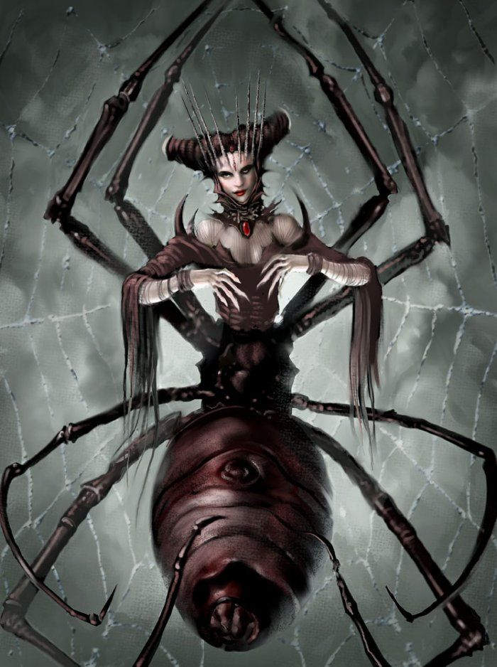
Athenerus
Appearance
Athenerus is part woman, part spider. She has eight huge, terrifying legs that are able to crush bones and metal. She has a luminous, scarlet stone around her neck that gives her special powers. Her lustrous, jet-black hair shimmers in the moonlight. On top of her head, she wears a crown of long, razor-sharp spikes.

Behaviour
Athenerus lives in the gloomy, haunted caves of Norway. She creeps into huts in the dead of night and snatches people from their beds as they sleep to feed to her nightmarish babies. She has a petrifying, haunting scream that can be heard in the dead of night.

Special Powers
Athenerus’ colossal, spindly legs can crush bones and metal. Her mystical, ancient amulet that she wears around her neck is able to hypnotize humans she meets. Athernerus is an intelligent killer, intelligent because she is able to read minds and lay traps with webs.

How to Defeat
Athenerus’ weakness is her large, swollen tail in which she carries her eggs. It is best to attack this tail with a sharp dagger as here her skin is soft. She is also terrified of water, terrified because she is unable to swim. If you can make her fall into water she would surely die.

