Hunter-Gatherers: The First Folks in Britain
The first humans arrived in Britain approximately 900,000 years ago. They lived in groups, with the skills needed to survive hard ice age conditions. This time in history is known as The Stone Age. This period of history is so long, it is broken into three smaller periods of time, the: Palaeolithic, Mesolithic and Neolithic. Earliest humans were hunter-gatherers; they survived by hunting animals and finding food to eat. They used flint tools to hunt animals, like deer and mammoths.

Where did they come from?
The first people came here all the way from Africa. They would have walked across mainland Europe because at this time, Britain was joined to mainland Europe. Therefore, prehistoric people crossed dry land where the English Channel is today. It is thought that the first people came to Britain following wild animals they hunted for food.

How did they live?
The first people in Britain were not modern humans like us, but an earlier species capable of hunting, tool-making and building fires and shelters. Palaeolithic people were highly skilled and lived in close-knit family groups. Hunter-gatherers did not settle in any one place permanently: they were nomadic, following the wild animals they relied upon for food and clothing. They were gifted tool-makers, able to make axes and tools from flint, wood and bone found in the surrounding landscape for hunting animals and preparing food. Interesting, they also gathered fruit and plants to eat such as.

What about the Ice Ages?
Ice Ages brought periods of extreme cold, forcing people and animals to adjust to increasingly hostile environments. At times, ice sheets covered large parts of Britain, so people could only live here during warmer, drier spells.

Who were the Neanderthals?
Neanderthals were shorter, more heavily built and much stronger than their predecessors. This helped them withstand the colder climates. It was only 40,000 years ago that modern peoples, Homo sapiens, began to appear in Britain, in the depths of the last Ice Age.

In the Neolithic era (the Late Stone Age), people learned to farm. They cleared large areas of land and settled down to live in small communities – abandoning their previous nomadic traditions. There were many developments through Stone Age. Despite misconceptions, hunter-gatherers were very skilled and intelligent beings – capable of surviving and thriving through the harshest times known.
Glossary
Palaeolithic: Old Stone (age)
Mesolithic: Middle Stone (age)
Neolithic: New Stone (age)
Flint: Type of sedimentary rock
Nomadic: is a member of a community of people who live in different locations, moving from one place to another.

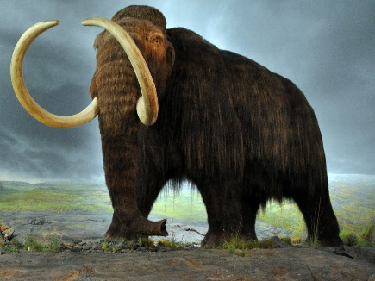
Animals that lived in pre-historic Britain:
- Mammoths
- Reindeer
- Woolly rhinoceroses
- Mega bear.

