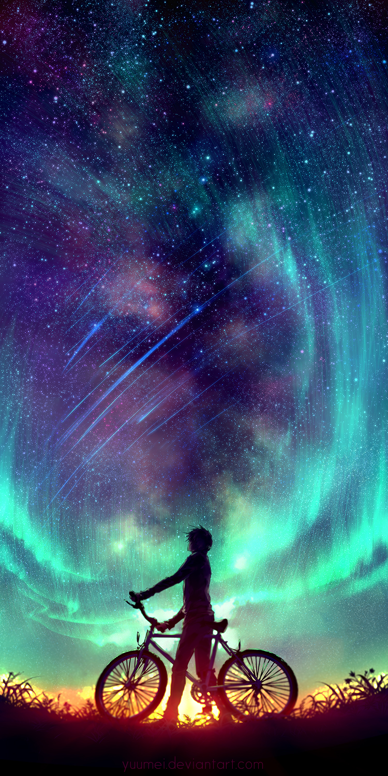
I knew I just needed to get away. As I peddled, my legs turned as fast as a jet engine. The blood was pumping through my body so loudly it was like a rush in my ears. When I rounded the final corner, I saw that my town was a small scattering of houses in the distance. Ahead of me was just the endless road, and the inky night sky. I gripped my handlebars tightly and pumped my legs even faster. I was a machine. Like the beam from a powerful torch, a single, bright light suddenly cut through the sky. Then another appeared, which was a beautiful, luminous green colour. After a while, thousands of tiny lights were shooting across the vast sky, like microscopic, silent rockets.

