The Wolf’s Perspective by Miss S

LI: I can write a flashback with dialogue

Africa has become a loyal friend despite being a human - he is such a kind, friendly boy and has excellent story-telling abilities. I often wonder if he will be my companion forever as we did not always get along.

In the beginning, and only a few months ago, I remember, he would just sit silently, staring opposite my enclosure, staring... staring. I didn't know what to do, he was such a hindrance and I was conscious of his silence. Pacing backwards and forwards I kept my eye on him when I could – he got on my nerves for a while; it was awkward. If those humans could have understood me I would have demanded to be set free but it was useless. I felt useless. Hopeless. Dead. Questioning my whole existence.

Despite this I became curious, wondering for hours, “What does he want?” and “Why is he here?” It was apparent he was not going to move so, intrigued and beguiled by the mystery of him, I began to listen and learn. As I looked into his eye, he revealed the story of his colourful life and I was transported on a journey across the vast continent of Africa itself. I felt no longer lonely because he became my companion, a teller of exciting stories, a saviour from my solitary existence and a life-long friend. I only had one eye back then, as the left one had been damaged by the human collectors years earlier but it did not matter – I was saved.

Since then, the zoo has become more bearable. It was - still is – different to being in the wilds of Alaska and this makes me melancholy, but at least I have someone familiar to talk to.

Without Africa my life would remain a prison cell, lonely, desperate and uneventful - I have new friends and feel complete now. Thank goodness I met him - I hope we will be friends together forever.

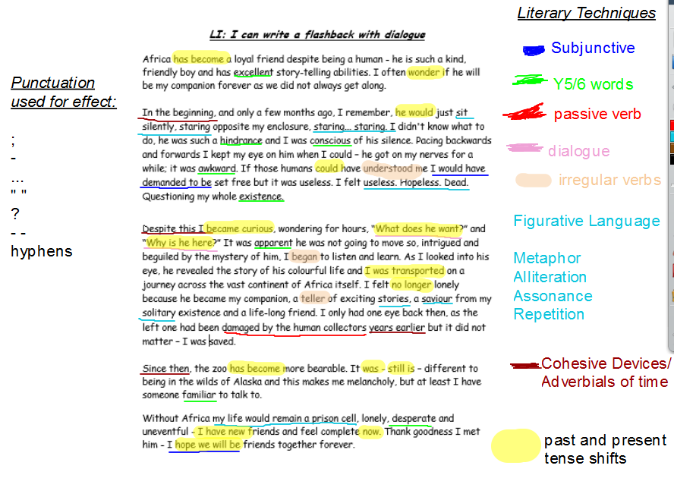

THIS PIECE SHOWS AWARENESS OF THE READER AS IT GUIDES THE READER THROUGH TIME. IT IS SIMPLISTIC AND NOT BUSY. IT USES PUNCTUATION ONLY WHERE NECESSARY = COHESIVE

