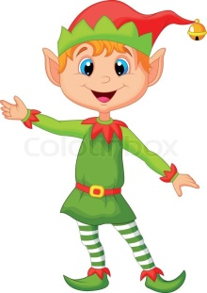
Thomas the Elf

Once there was a young, kind elf called Thomas. He lived with lots of other happy, little elves in the North Pole. Snow always fell gently on the ground there. Thomas was full of happiness.
One day, Thomas decided that he wanted to deliver a Christmas card to his very special friend, Evie. She lived on the other side of the town. Carefully, he made it all by himself. How proud he was!
Excitedly, Thomas set off on his journey to deliver his big, red Christmas card. Thomas forgot to take his map of the North Pole with him and sadly he couldn’t remember the way to Evie’s house! It was getting dark and Thomas could not see. He felt very scared and alone.
Luckily, he remembered what Santa had taught him at elf school. He needed to call a very special animal to guide him home. “Rudolph!” he shouted. In the distance, Thomas saw a glowing light coming towards him. Rudolph had heard him come.
Rudolph took Thomas back to the other side of the North Pole safely where Thomas decided to send the letter by post instead!
The end

