Trapped
Chapter One: Rumours
The Swallow had been travelling to the space station for over four days now and her passengers had been getting to know each other. The children were the latest recruits to be sent to Earth’s Future Astronaut Program; they were to be trained up to be mankind’s last hope to find a new home away from Earth’s polluted, overcrowded megacities.
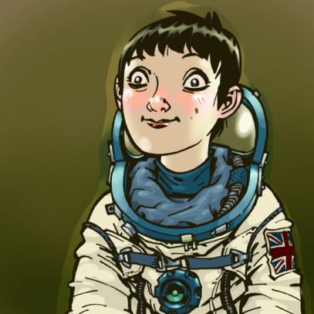
Jane McCoy was jolted out of her day dream and looked around the cabin. She was tall for her age with wide, hazel eyes. Her off-white space suit was ill-fitting but she remembered the pride she felt when she was handed her Union Flag patch to attach on her left shoulder. She brushed her hair to one side, a nervous habit. Her hair, which was the colour of muddy water, was cut short but still managed to stick up at odd angles no matter how hard she tried to get it under control. She looked around and saw the girl in the corner of cabin sitting on the floor.
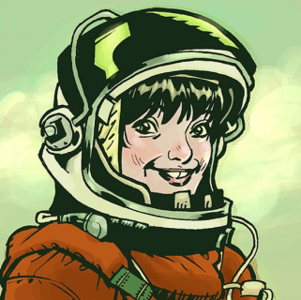
The French girl, Camile Piccard, had been practising her English on the other four passengers with little success. The main problem with being trapped on a ship with four geniuses, she thought, was that they often tended to be slightly odd.

“Did you hear about the Raven?” Camile asked the group.
“I heard they all disappeared in mysterious circumstances,” said Jane, glad to talk about something. She turned to look at whatever it was that made the dismissive snort to her left.
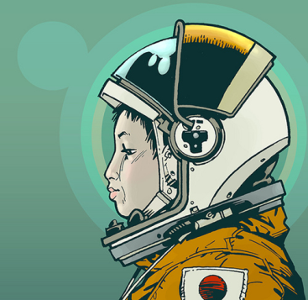
“We heard all of the rumours in Yokohama,” grunted the quiet Japanese boy in the corner. Up until now Hiroshi Sulu had been silent throughout the voyage. Silent, but always watching them. He wore coloured contact lenses: one blue and one green. According to Camile, he wanted to look like the famous celebrity scientist, Dr. Yoshi Saitama. “Apparently,” he continued sarcastically, “They were all eaten by little green men.”
“Well, why do you think they all vanished then?” said Jane, “All the escape pods were locked down and the computer was wiped. It doesn’t seem that ridiculous to me that aliens did it.”
“Sure, replied Hiroshi, “Aliens took everyone on the ship. That must be the answer.” He sighed and began to tap at his tablet.
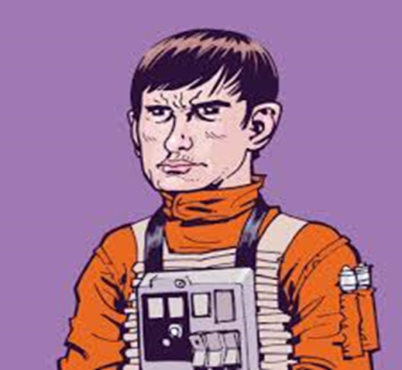
The other two passengers of the Swallow were busy on the ship’s on-board computer. Vladimir Chekov, who had been sent by Roscosmos (the Russian Space Agency), was tall for a ten-year-old. He had a harsh face and was, according to his file, an expert at mechanics. His orange space suit had splashes of oil on the sleeve and his hard, green eyes drilled into the computer screen as he turned to the girl on his left.
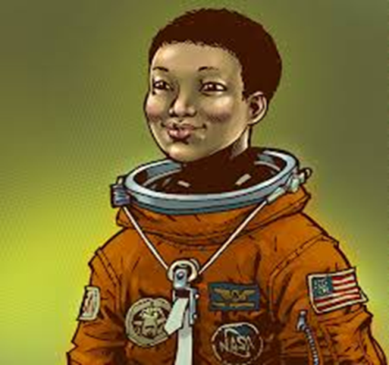
Faith Uhuru had been born in Chicago but had moved all over the United States with her parents. They lectured in quantum physics and recently had been working on something for the government. Big men in dark suits had followed her family around. Her mother told her that they had been sent to look after them but they never smiled and hardly ever spoke except to refer to her as ‘short-stuff’.
Faith looked worried. “It doesn’t make sense!” she whispered under her breath.
“What?” replied Vladimir in his thick Russian accent.
“There’s no response. No reply. I keep hailing them but they don’t answer. Why won’t they reply?” Faith’s face looked increasingly concerned.
“We will find out soon enough. The autopilot is bringing us in. The computer says we will have docked in 32 seconds. It’s probably a communication issue with their transmitter.” Vladimir muttered unconvincingly.
The computer began to beep as the thrusters fired to slow down the Swallow. There was a loud crunch then a pop as the ship docked and the pressure equalised. The bolts on the door moved and as the door began to groan and shudder Jane wondered what waited for them on the other side.

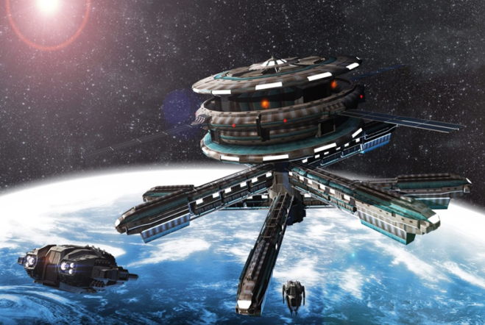

Chapter Two: Abandoned
As the doors opened, the pressure between the children’s spacecraft and the space station equalised. Jane looked around and was disturbed by what she saw. The vast, empty room was filled with complaining dusty, grey pipes. Faint red scratch marks covered the side of the left wall whilst the gentle hum of the stations engines filled the ears of the three newcomers. The air was filled with an acrid smell and Jane could taste the dry, bitter air. The station was deserted.

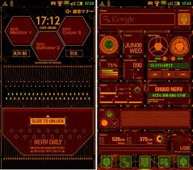
The computer console, which flashed with a worrying red blink, was emitting a frightening tone and the door was as cold as ice to touch. Smooth, metallic hand rails lead Jane and the others up the hard, rough steps to the worried computer which looked as though it had been flashing this warning signal for some time.
“Where is everyone?” Jane asked.
“They must have been evacuated?” replied Hiroshi nervously.
“I think we need to explore the station to find out for sure,” Said Camille, whilst she looked nervously behind her.

Chapter 3: A Survivor
Jane led the others past the flashing, dust-covered computer screen down the long hallway. The lights overhead blinked on and off and the station groaned at the three unwelcome guests.
Camille stopped and pointed silently towards a broken sign on a door that read: Captain Shepherd. Jane lent forward and listened at the door as Hiroshi stared into the blackness of the corridor appearing unsure of what he was looking for.

Inside, in the corner, was a wild-eyed and dishevelled man in a captain’s uniform. He had a deep scratch down his left cheek and his right hand was covered in blood that did not look like his own.

“They can hear you.” He mumbled, “They’ll be here soon.” He fixed them with his stare. “The dark! They come for you in the darkness!”
Hiroshi looked up and then at the others. His normally impassive mask slipped and his face was an ocean of concern. He pointed to the exit. His meaning was clear: they needed to escape.
Along the corridor, they ran towards the exit. The lights flickered and a faint scratching sound came from above them.
“Not again. Not again.” The captain mumbled repeatedly to himself.
All of a sudden they were bathed in a terrible, deep darkness which spurred them on towards the light of the station’s canteen. The scratching grew louder and louder and louder accompanied by a crash as one of them fell.
As the children reached the safety of the canteen, they realised that something was wrong. The captain and Vladimir were missing and in the darkness of the corridor they could see the same faint red scratches on the wall they saw in the docking bay.
“Where is he?” Faith said. “Where is he?” She was becoming more and more agitated. “We need to leave. Now!”
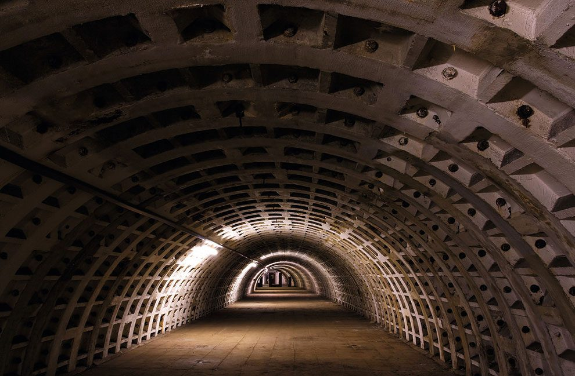
The lights flickered again and again the faint scratching noise began above their heads.
Hiroshi looked at them. “Run!” He shouted. And they did.
Towards the last escape pod, they ran faster and faster. The terror of what lay behind them added to their speed. The children knew that their choice was simple. They had to escape or die.
The light of the escape pod bay welcomed them in and as the children arrived panting and scrambling they clawed at the computer panel and the hatch began to creak and moan as it obeyed the order to let them in. Hiroshi and Jane looked at each other and as they did their faces changed. The growing realisation dawned on their faces. There were only two of them. They turned and saw, on the edge of the canteen, now bathed in darkness, the French patch from Camille’s space suit and a red stained square of orange fabric, amidst the faint red scratch marks on the wall.

Chapter 4: Escape
A tear rolled down Jane’s face and she fell to her knees and sobbed. She knew she was safe now. Once they got into the escape pod they could leave the horror of the space station behind them. The government needed to know about this.
As Jane mourned the death of her new friends, Hiroshi moved silently into the escape pod and the air-lock closed with a hiss. Jane turned, illuminated by flickering lights, looked at Hiroshi and was rendered speechless by his betrayal. Hiroshi flicked the switch next to the intercom.
“They sent me to confirm the reports,” He sighed, “I had to confirm the reports and silence any witnesses. Imagine the panic on Earth if this got out. Humanity would never leave Earth again. It’s the only way. I’m sorry.”
As Hiroshi mouthed his apology, the room was filled with darkness. He flicked off the intercom and turned to pilot the escape pod back to Earth. He knew what was coming from the dark and had no desire to hear it again.
