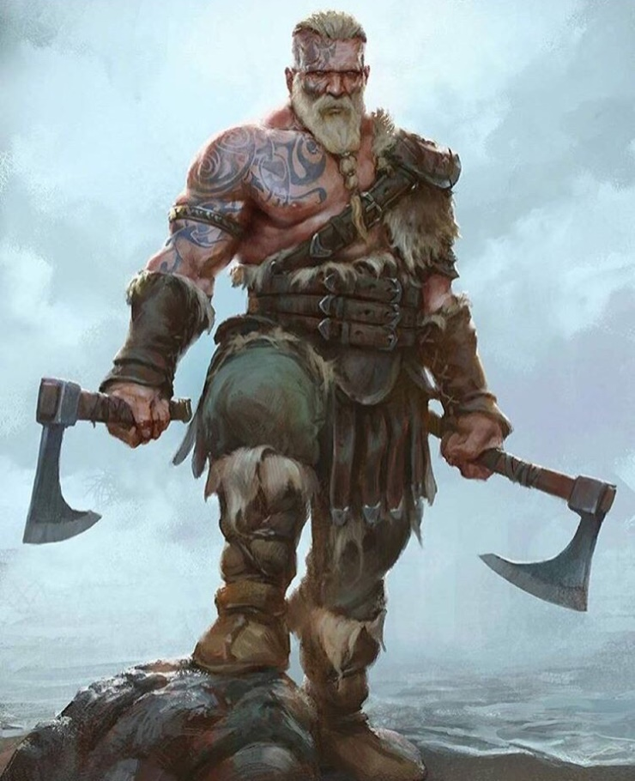

The Viking was a tall, terrifying man. He had long, yellow hair and shiny, blue eyes. He had a rough, tangled beard and huge, strong arms. He had dark, blue tattoos on his body and face.

He wore tough, brown leather armour around his body. He had long, brown gloves on his arms to protect him in battle and dirty, green trousers on his legs. He wore thick, ancient belts around his waist that he used to carry things that he had raided.

In his hands he held two huge, sharp axes that shone in the sun. He used these powerful, heavy weapons in battle to defeat his enemies.

As he stood on the cold, wet rocks near the ocean, he scanned the ground in front of him for enemies. He thought about the wondrous, golden treasure that he could steal on this raid.

He had big, strong arms. He wore soft, brown boots that were made of deer skin and tough, brown armour that was made of leather. In his hands he carried two large, sharp axes that were used to fight battles. He had