Volcanic Panic!!

As the sun crept through the lip of the window frame, Jason was just stirring. It had been a long day yesterday. The team had flown out to the island of La Palma early the previous morning and had made their way to the base of the volcano. Today was the most important day of the trip and Jason knew this, which was why he was getting up at the break of dawn. He peeled his eyes open, yawned, stretched and the rolled out of bed. Wiping the sleep from his eyes, he thought about the day ahead and about their target of reaching the volcano’s summit. Jason was a young scientist and this was his first trip to a real volcano. He had studied them in books but never seen one up close. The thought of him finally seeing the steaming, churning lava gave him goose pimples. He grinned to himself as he put his trekking boots on.
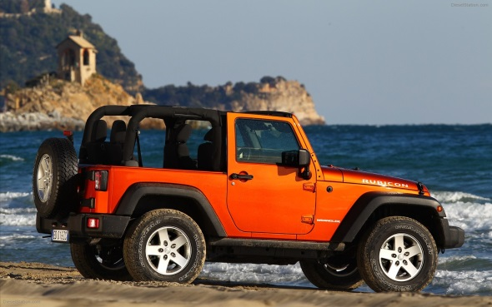
A few moments later, Jason stepped out into the purple haze of the early morning. The sun was just peeping over the coastline and the early morning fishers bobbed like shadow puppets on the still ocean. Yawning, Jason began to load the jeep with the equipment that was needed. He loaded ropes, thermometers, climbing equipment, food and plenty of water. He could tell by the rising humidity that it was going to be a scorching day.
“Morning!” A ruby red haired young lady was stepping out of her lodge. It was Lucy, who was still putting on her boots as she stumbled towards the jeep. Her hair looking a little wild as though she had just woke up moments before. “Are we all packed?” she croaked.
“I think so!” Jason replied excitedly. They checked the inventory list, closed the jeep boot and jumped into the four wheeled machine. The engine grumbled into life and the wheels spun in the smooth sand. Jason revved the engine a couple of times and then off they both set towards the volcanic trail.
5 minutes later, the jeep was crawling up the dirt track towards the volcano’s summit. The road was much steeper now and the surroundings had changed dramatically. Where golden sand once lay, the ground was now hidden by thick, emerald green jungle. Vines and branches intertwined and curled round like dancing snakes. Through the open window of the jeep, Jason could hear the birds singing and beetles hissing. The temperature had risen now and the sun was making its own way towards the top of the volcano. Jason’s excitement was growing. He looked over at Lucy who was also grinning in anticipation.
As they reached the top of the volcano the road became much more uneven. Lucy gripped hold of the jeeps ceiling handle to stabilise herself. Jason found an open clearing – perfect for parking the jeep. Turning the key, the engine shuddered off, leaving an eerie silence that grabbed Jason and Lucy’s attention. The forest had fallen silent. There were no calling birds or hissing beetles. It was as though the animals had all been evacuated. They loaded the equipment onto their backs and trudged the 100 meters towards the volcanic crater.
There was a sudden cracking of twigs to the right and 30 to 40 birds broke through the tree canopy and flew high up into the air. Lucy jumped in surprise. “What spooked them?” she asked.
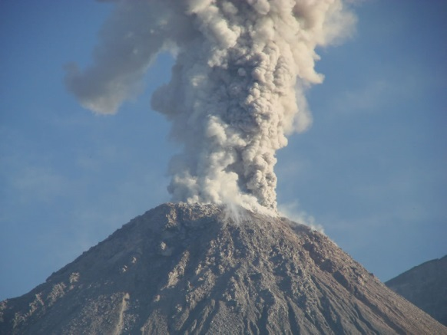
“Probably our clunking rucksacks!” replied Jason with a frown on his face, but the excitement of seeing the bubbling lava overshadowed his anxiousness. He could see the steam now rising from the crater. This was it… this was the moment he had been waiting for…
Without warning, Lucy stumbled and fell to her knees. There was a deep grumble from somewhere underneath them both that made both of them freeze to the spot. A long slow cracking like the ground was ripping in two pierced their ears. Suddenly, the earth began to pulsate and shake vigorously. Jason lost his footing too and they both fell on all fours and clenched the juddering rock.
“Earthquake!” Lucy screeched over the growling of the earth below. Moments later the situation became an emergency. 10 meters away, from the deep hole of the volcano, came a colossal explosion that seemed to rip upwards. A huge mushroom of ash, dust and smoke hurled far up into the air. The dormant volcano was active!!!
Jason grabbed Lucy’s arm. “Come on!” he yelled. They both scrambled to their feet and began to stagger back down towards the parked jeep. The ground was still quivering violently but that was nothing compared to the scorching ash that was now falling all around. They had to get as far away from here as possible. However, as they turned the corner they were both met with a new problem to overcome…
Oozing across the rocky trail was a wide, sizzling river of lava. The molten rock bubbled and hissed as it gushed down from the crater, across the road and burned an alley of flaming jungle. Luckily, the jeep was standing sturdily but it was on the other side of the blood red lake.
Without taking a second to think, Jason dashed towards the lava which bubbled and spat outwards burning tiny holes into both of their cloths. Jason sprang onto a rock that jutted out from the burning river, being careful not slip as he knew his foot would be melted away in seconds. He began to step from rock to rock like stepping stones. Lucy followed. They had to be quick because the lava was corroding the stones away.
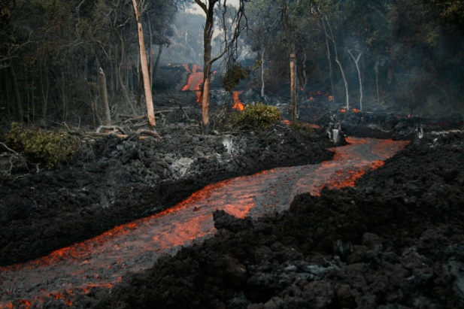
As soon as they reached the other side they both darted towards the van, coughing due to the gas and smoke. Opening the door, they both scrambled into the jeep. The engine erupted into life and Jason hammered his foot down on the accelerator. The wheels screeched across the shaking crumbing floor and began the long decline back down the hill side.
KABOOM! Another explosion echoed from behind, this time forcing a vast ash cloud towards the jeep. “Step on it!” Lucy wailed. Jason slammed his foot to the floor. The ash cloud was approaching fast. Jason and Lucy were thrown from side to side. Although the jeep roared onwards, the ash cloud advanced further. Sweat was now pouring down from the explorers’ faces. If only they could just reach the safety of the science lodge. Lucy looked over her shoulder. Trees toppled like cards whilst the cloud smashed through them with ease. Leaves erupted into flames. Fire swallowed everything in its path. Ash fell like grey snow. Lava bombs dropped and exploded all around.
Hitting the base of the volcano, Jason slid the jeep round the corner, bringing the lodge into sight. “Look out!” Lucy pointed towards the ground 500 meters ahead, which had now also become a victim to the river of scolding lava. The bridge, that once stood there, was no more. Only a few beams remained. “We can make it!” said Jason. He seemed determined to survive. Wheels spinning, he sped the vehicle towards the broken bridge. Lucy once again clenched hold of the ceiling handle and closed her eyes. The tires hit the first few planks of wood, which catapulted the jeep up into the air and over the steaming river. The front of the car, crashed down to the ground and it bounced towards the lodge.
Jason yanked the hand break causing the jeep to skid into a standing position, spraying mud towards the lodge windows. They both leaped out of the jeep, covering their mouths to stop them breathing in the toxic gas. Entering the lodge, Lucy slammed the door shut and they both entered the safety bunker down the stairs. They could hear the ash pattering on the roof. They both gasped for breath and their hearts pounded. They were safe for now but for how long?...

