Wolves
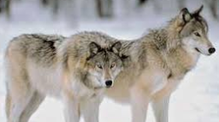
Appearance
A wolf is a large, wild dog. Most wolves look similar. Their bodies are shaped like a pet dog but bigger. They have thick, bushy fur. Wolves have fangs to help them catch their prey. Male wolves are bigger than female wolves. Wolves can be grey, red/brown, white and black. The colour of their fur depends on the environment that they live in. Some wolves have a white coat in winter (to camouflage in snow) and a grey one in summer (to camouflage in rocky mountains). All wolves have large paws with sharp claws.

Habitat
Wolves are highly adaptable which means they can live in different habitats including the tundra, woodlands, forests, grasslands and deserts. Wolves are social animals and live in packs. They sleep out in the open, even when it’s snowing!
Diet
Wolves are carnivores which means they eat other animals. Their diet usually consists of large hoofed mammals, like elk, deer, moose and caribou, as well as beaver, rabbits and other small prey. They hunt for their prey in packs.
Wolves are also scavengers and often eat animals that have died due to other causes.

Did you know wolves play tag, push and shove, wrestle and chase each other? The alpha female and alpha male of a pack usually mate for life.

